Tirumala Reddy Konireddy

Krishna Chaitanya Nalluri

Lab 05 report

Sensor Data Collection and HBase Uploading and Retrieval

**Open Source Android Game**

I had chosen the Open Source Android Game TheGot2Run Game for our Lab 5 Assignment.

**Modified Code**

I had used a connection service program to connect the Android game to BLE Sensor Tag and extract Accelerometer data of BLE Sensor Tag.

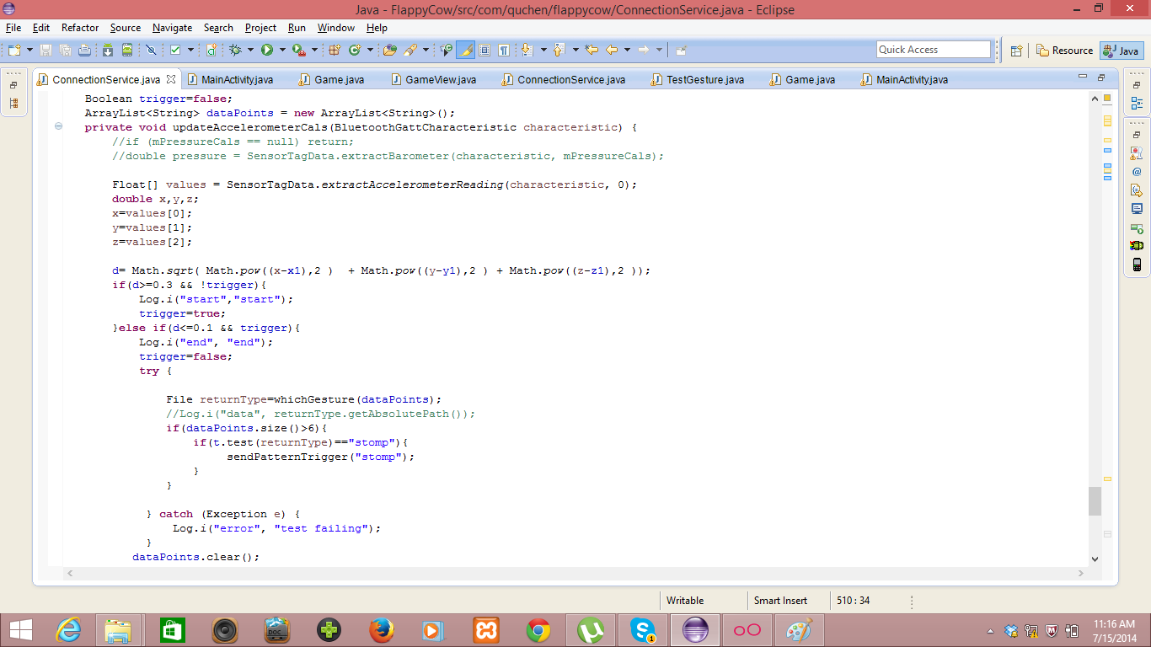

I am using a distance vector calculation formula inorder to capture the motion.

i.e., D = √(x1-x)2 +(y1-y)2+(z1-z)2

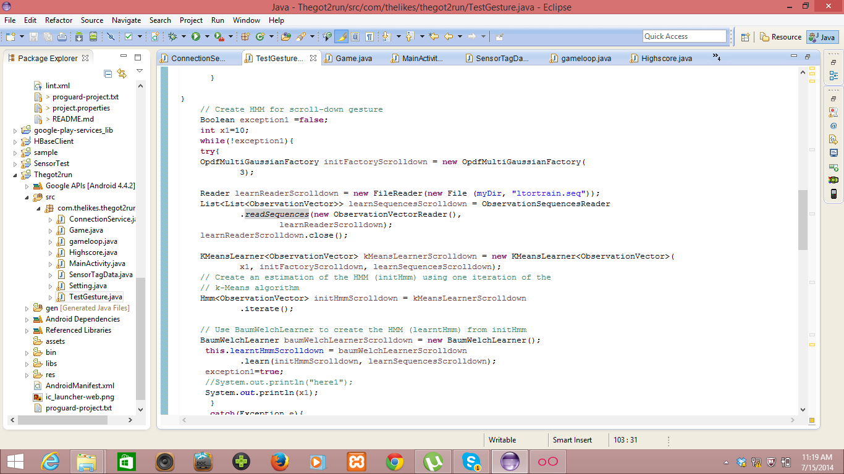

We had used a broadcast receiver service for broadcasting accelerometer data to all activities running on Android Operating System as above.

We had used the Sensor Tag extraction data class for accelerometer data extraction.

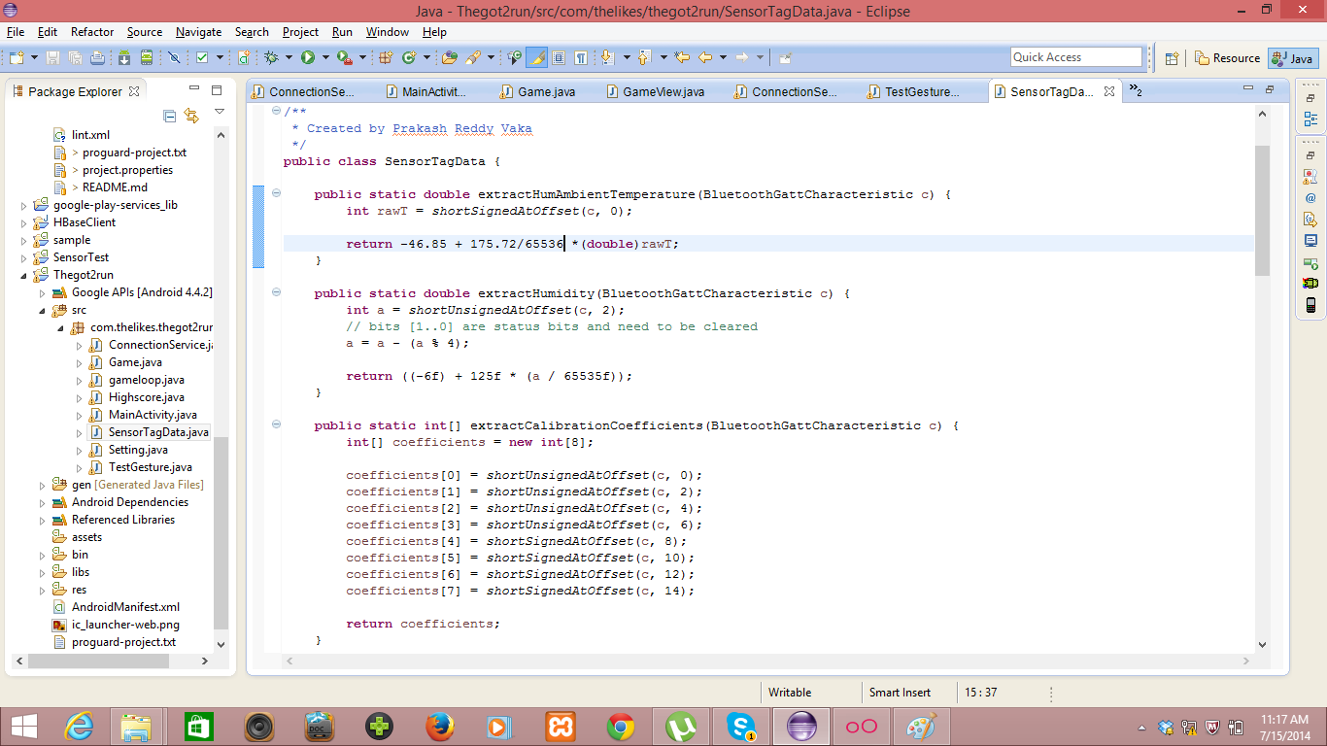

**Modified Got2RunCode:**

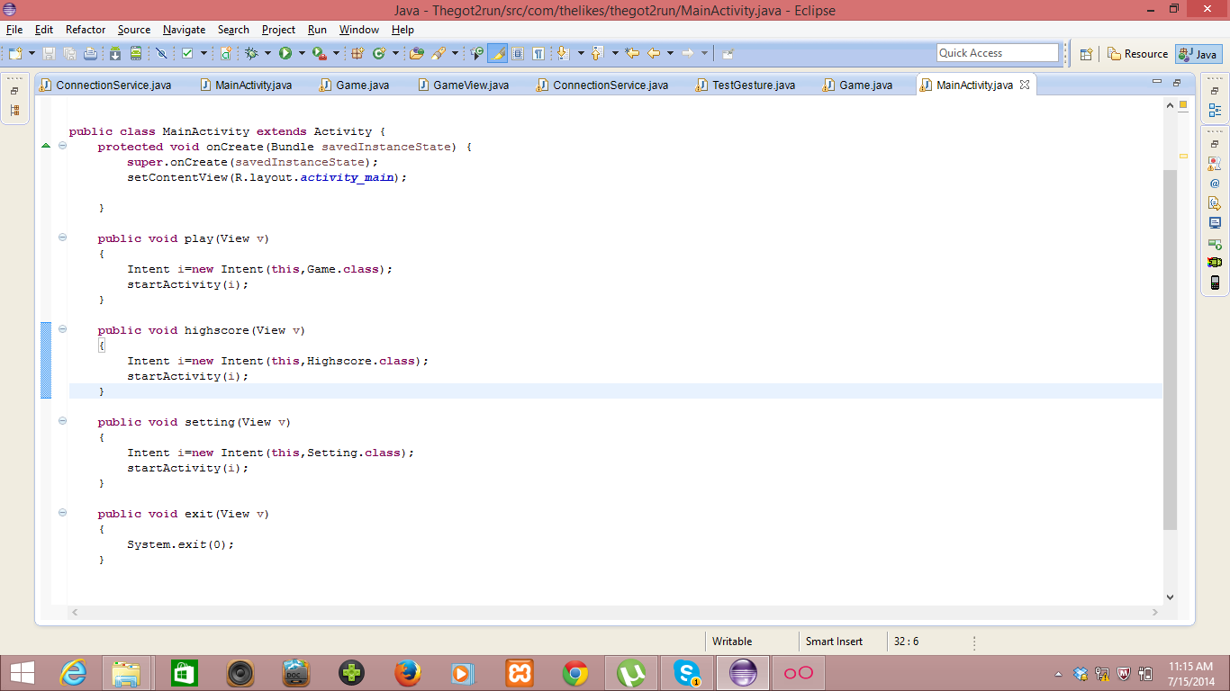

**Receiver of Broadcasted Accelerometer Data:**

Receiving of Broadcasted Accelerometer Data.

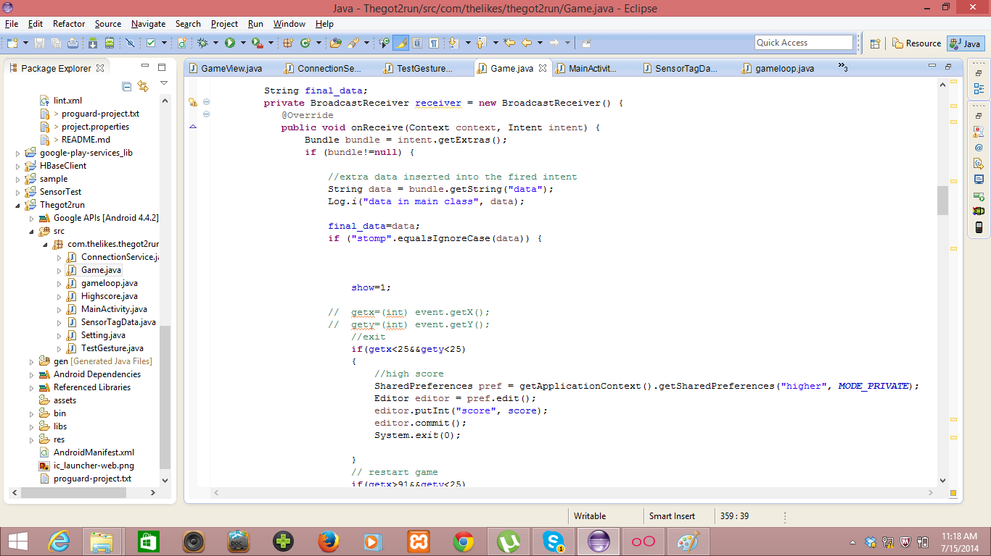

Here we are checking whether a motion is captured or not and trigger the jump activity in Android Game.

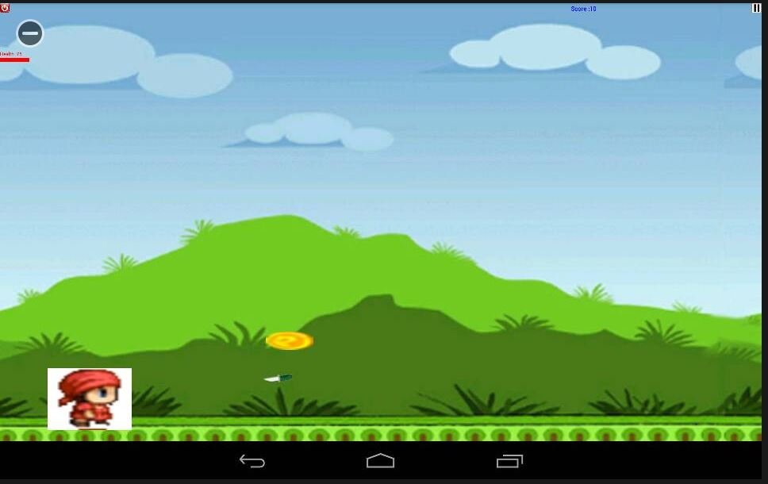

**Jump**

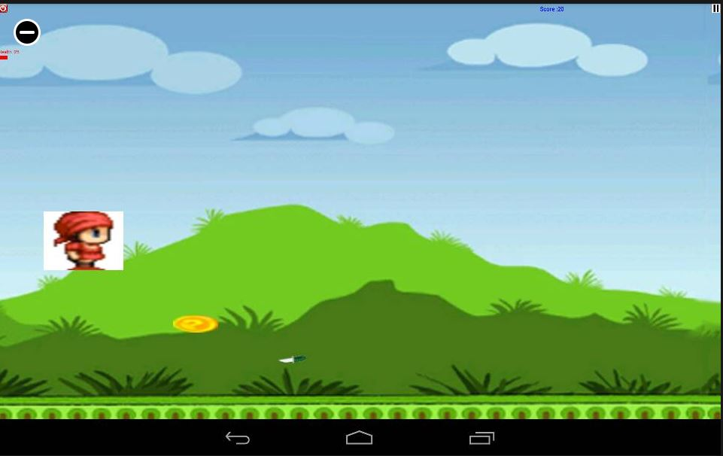

I had tested all my three gestures as below.

**Hungry gesture captured in Logcat:**

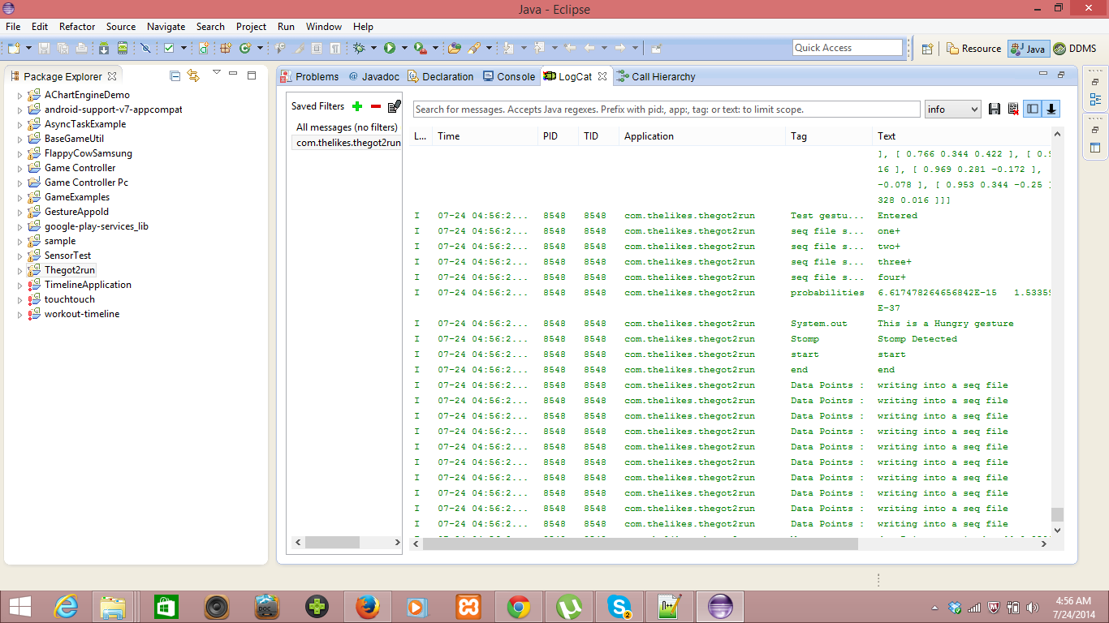

**Game Play gesture captured in Logcat:**

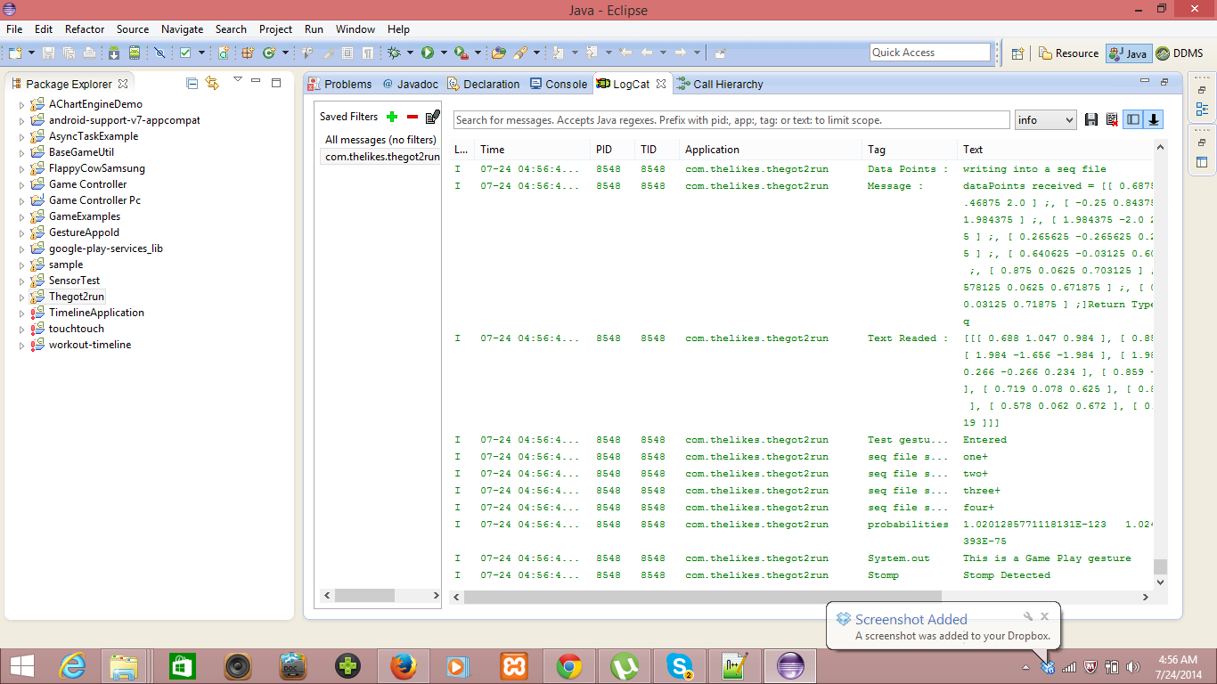

**Thirsty Gesture captured in Logcat:**

